INSTRUCTIONS FOR UPLOADING ONLINE ART PROJECT
Online art project is an important part of Kala Utsav entry from States/ UTs to the National Level. The students can complete their online projects with easy to use equipment, such as cell phone, which they are already using for social media such as: WhatsApp, Facebook, Twitter, Instagram, Hangouts, etc.
The entry of Online Art Project will begin by 1st of December, 2017. All the four online Art Projects should be uploaded on YouTube by midnight 11:59 o’ clock of 15th December, 2017. Each of the online Art Project should contain the following details:
1. Title of the project: (write the title of the online art project)
2. Language: (select the language of your online art project)
3. Description/Background of the project (in 500 words): This will be required for the website and for the printed document on Kala Utsav – 2017. (This section should provide the basic information of the art form. It should contain the historical background of the art form, the region it is being practised in, and whether it belongs to a community or not. Artists who have promoted the art form. How is it practised? Is there any special occasion attached to it? Is it a living traditional or a dying art form?)
4. Processes of the project (in 500 words): This will be required for the website and for the printed document on Kala Utsav – 2017.
(It should contain a brief description of the different stages of the project including the idea, selection of the theme/ content/ form of the art, etc.)
5. Duration: Duration of the film/video on online projects should be minimum 6 minutes and maximum 8 minutes.


How to upload Online Art Project on You Tube

To upload the online Art Project on YouTube, follow the following steps:
STEP 1: Please click on YouTube www.youtube.com and click on Upload tab (right side corner of the screen)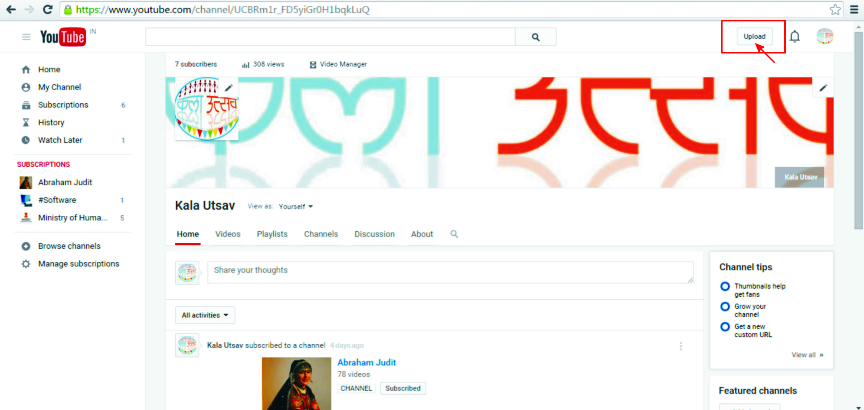

Step 2: A new upload window appears, then click on 'Select file to upload'
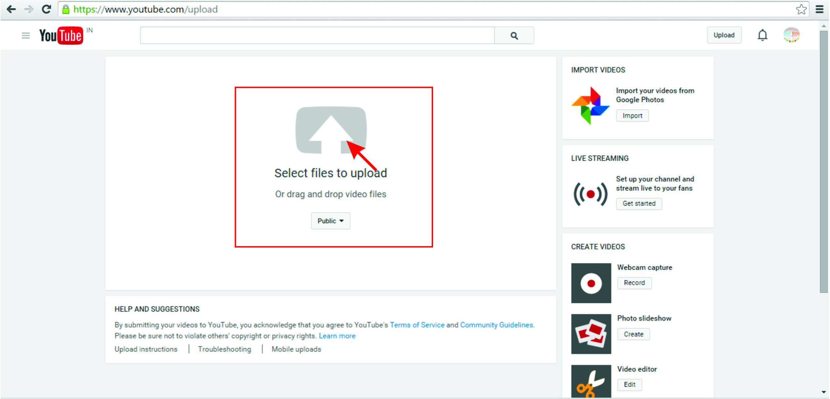
Step 3: When you click on 'Select file to upload' then an Open window will appear. You have to select your e-project and click on Open tab; then your e-project will start uploading.
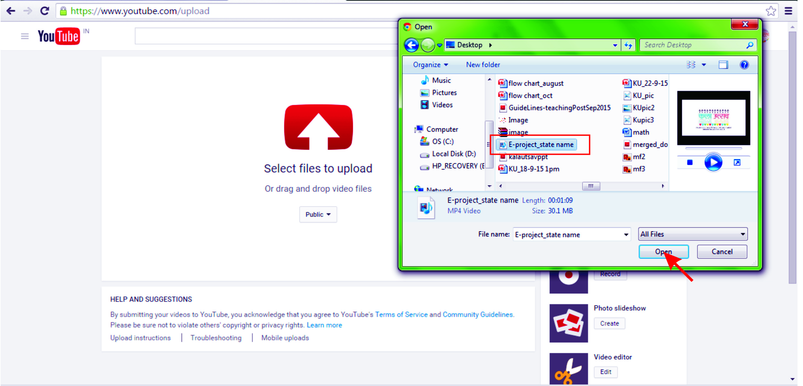

Step 4: When your e-project is uploaded, then click on the Publish tab. This will complete uploading.

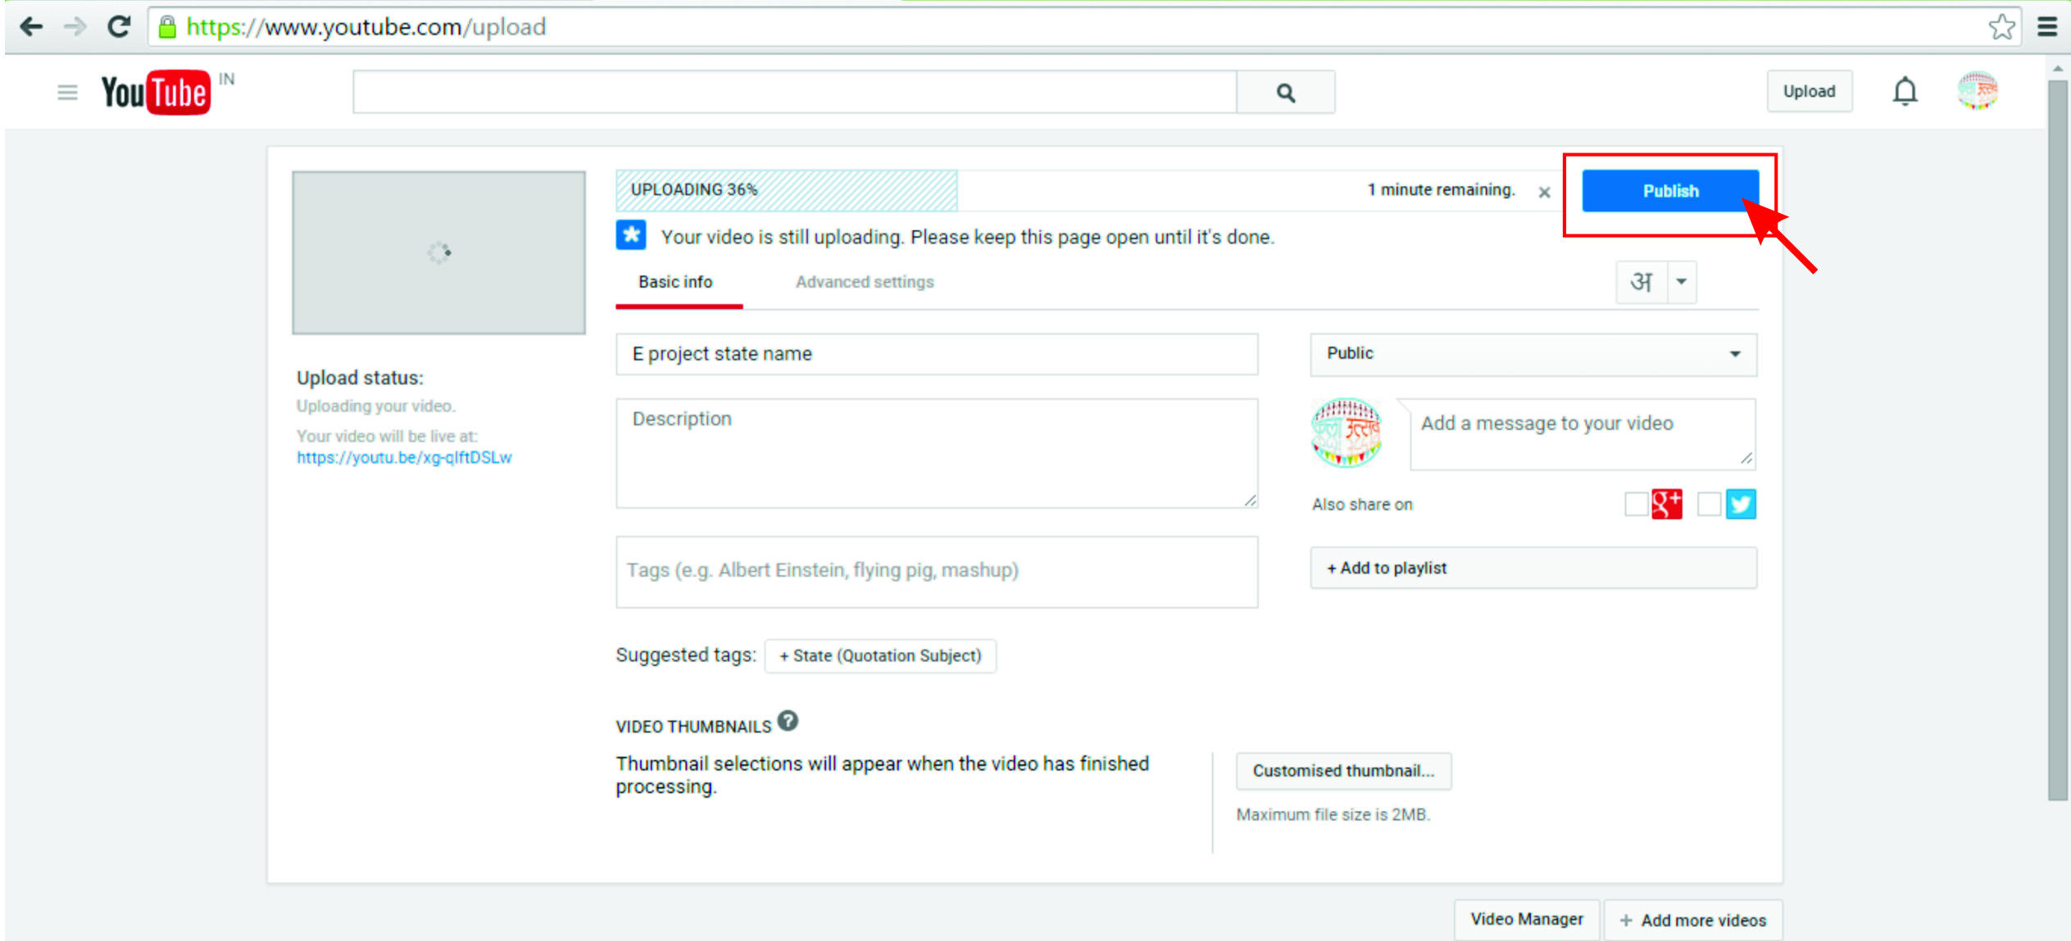

This will publish your Online Art Project on YouTube. After successful upload, the following details need to be mailed on Kala Utsav email id- kalautsavncert2015@gmail.com
- The YouTube URLs of all four Online art Projects category wise, i.e. Dance, Music, Theatre and Visual Arts.
- The 500 word write up of the Description/ Background of the Online Art Project.
- The 500 word write up of the Process of the Online Art Project.
- All the four entries from the state/UT shall be seen and approved by the state/UT Nodal Officer before they are submitted for the National Level. Declaration form for authentication is given in Anexure-II of Kala Utsav 2017 guidelines. A scanned copy of the Performa for each art form should be attached in the email.

